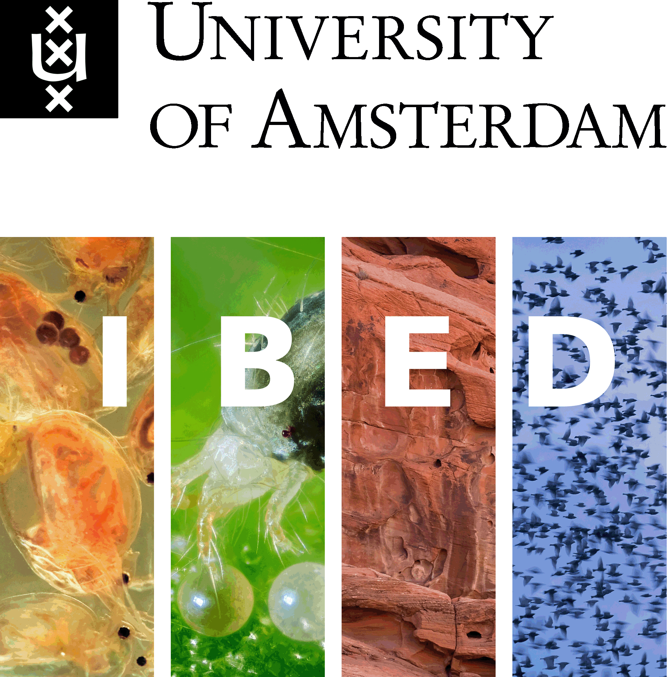

Summer Course Animal Movement Analysis
30 June - 5 July 2019, Amsterdam
Scope
The aim of this course is to provide participants with skills to assist them in working with animal movement data including data management and organization, working with large tracking datasets, data exploration, visualization, annotating track data with environmental data and analysis of movement data. The course is also a great opportunity to develop your research network in the field of movement ecology. The course content is relevant for participants studying movement in a broad range of taxa and environments, however there is an emphasis on birds in the course exercises as most exercises use an existing bird tracking dataset. Participants will learn about the strengths and weaknesses of different tracking technologies for diverse taxa. The course will combine several guest lectures from international experts in the field of animal movement ecology, predominantly hands-on computer work, field experiments with GPS trackers, presentations given by participants and focal workshops on the last day of the course. During the course different software packages will be used with most of the work conducted in R, and participants will learn some basic programming and database skills. Course participants are expected to familiarize themselves with R before the beginning of the course, and materials for self-tuition will be provided in advance.
Course lecturers and organizers
Judy Shamoun-Baranes University of Amsterdam - Institute for Biodiversity and Ecosystem Dynamics
Willem Bouten University of Amsterdam - Institute for Biodiversity and Ecosystem Dynamics
Emiel van loon University of Amsterdam - Institute for Biodiversity and Ecosystem Dynamics
Bart Nolet Netherlands Institute of Ecology (NIOO-KNAW)
Elspeth Sage University of Amsterdam - Institute for Biodiversity and Ecosystem Dynamics
Morgan Brown University of Amsterdam - Institute for Biodiversity and Ecosystem Dynamics
Johannes de Groeve University of Amsterdam - Institute for Biodiversity and Ecosystem Dynamics
Felix Liechti Swiss Ornithological Institute
Geert Aarts Wageningen Marine Research
Simone Ciuti University College Dublin
Amber Heijboer Graduate School PE&RC

Course schedule Animal Movement Analysis 2019
L = lecture, C = computer exercise, D = group discussion, F = fieldwork
The course will be conducted in Science Park 904, 1098 XH Amsterdam. The lectures and computer exercises will be held in room F2.04. Note that the building is closed after 18:00.

Sunday, June 30 (Oerknal, University Sports Centre, Science Park 306, Amsterdam)
17.00 – 18.00 Welcome & registration
18.00 – 19.00 Poster Session
19.00 – 21.00 Dinner

Monday, July 1
Software: SQLiteStudio, R
Instructors: Judy Shamoun-Baranes, Morgan Brown, Emiel van Loon
8:45 – 9:00 F2.04 Arrival and coffee
9:00 – 9:15 L Opening, Judy Shamoun-Baranes
9:15 – 12:00 L/C Introduction to course dataset & working with databases, Judy Shamoun-Baranes
C Working with a relational database: exploration and management of movement data, selecting, filtering and aggregating data
12:00 – 13:00 Oerknal Lunch break
13:00 – 14:00 L F2.04 Drivers and consequences of avian movement, Judy Shamoun-Baranes
14:00 – 15:00 L/C Introduction to exercise: calculating basic movement statistics and visualizing data in R, Morgan Brown
C Calculating basic movement statistics in R
15:00 -15:30 Coffee break
15:30 – 17:00 C Continue exercises
Calculating basic movement statistics in R
Visualizing data in R: scatter plots and histograms
17:00 – 18:00 Academic break – time to review your work and practice at your own pace
18:00 Oerknal Group dinner @ Oerknal
Tuesday, July 2
Software: R
Instructors: Elspeth Sage, Emiel van Loon, Judy Shamoun-Baranes
8:45 – 9:00 F2.04 Coffee
9:00 – 10:00 L Understanding bird movement behaviour in response to dynamic environments, Elspeth Sage
10:15 – 10:30 L/C Introduction to exercise: Integrating environmental data and animal movement data, Elspeth Sage
10:30 – 12:00 C Integrating environmental data with tracking data in R
12:00 – 13:00 Oerknal Lunch (+ group photo)
13:00 – 14:00 L F2.04 Modelling migration, Bart Nolet (UvA, NIOO).
14:00 – 15:00 C Integrating environmental data with tracking data in R & time budget analysis
15:00 – 15:30 Coffee break
15:30 – 17:00 C Continue exercises and short wrap up
17:00 – 17:45 Academic break – time to review your work and practice at your own pace
17:45 – 19:00 Oerknal Dinner @ Oerknal
19:30 – 20:30 Special activity: active movement workshop
Location: Studio 2, University Sports Centre
Required: positive energy, light and loose clothes for physical activity.

Wednesday, July 3
Software: R, Google Earth
Instructors: Willem Bouten, Judy Shamoun-Baranes, Johannes de Groeve, Elspeth Sage
8:45 – 9:00 F2.04 Coffee
9:00 – 10:00 L Fundamentals of GPS tracking, Willem Bouten
10:00 – 10:30 L Introduction to experiment: Working with GPS loggers, Willem Bouten
10:30 – 13:00 F Experimenting with GPS loggers including lunch break: pick up bagged lunch at Oerknal
13:00 – 14:00 L F2.04 Monitoring biomass in the aerosphere by radar and relating it daily flight patterns of individuals, Felix Liechti (Swiss Ornithological Center)
14:00 – 15:00 C Visualizing GPS data (trajectories, summary plots) and exploring GPS performance characteristics
15:00 – 15:30 Coffee break
15:30 – 16:15 C Continue exercises
16:15 - 17:15 D Student presentations of experiment results and group discussion
17:15 – 18:00 Academic break – time to review your work and practice at your own pace
18:00 Oerknal Dinner @ Oerknal

Thursday, July 4
Software: R
Instructors: Emiel van Loon, Simone Ciuti, Judy Shamoun-Baranes, Morgan Brown
8:45 – 9:00 F2.04 Coffee
9:00 – 10:00 L Integrating methods to study seal movement and distribution, Geert Aarts (Wageningen Marine Research)
10:05 – 10:30 L Introduction to exercises: home range analysis and utilization distributions, Emiel van Loon
10:30 – 12:00 C Calculating home ranges, utilization distributions, core areas and areas of intensive use: exercise in R
12:00 – 13:00 Oerknal Lunch break @ Oerknal
13:00 – 14:00 L F2.04 The concept behind a Resource Selection Function (RSF) and its applications in ecology and conservation, Simone Ciuti (University College Dublin)
14:00 – 15:00 L/C How to build an exponential RSF using mixed-effect models, Emiel van Loon & Simone Ciuti
15:00 – 15:30 Coffee break
15:30 – 16:30 C Continue exercise
16:30 – 17:00 D Wrap up and discussion (including tricks and tips in RSF analysis) led by Emiel van Loon & Simone Ciuti
17:00 – 18.00 Travel to excursion
18:00 – 19.30 Dinner @ Naardermeer
19:30 – 21.00 Hike and bird watching around part of Naardermeer
21.00 – 21.30 Return to Amsterdam

Friday, July 5
Instructors: Willem Bouten, Emiel van Loon, Simone Ciuti, Felix Liechti, Judy Shamoun-Baranes
8:45 – 9:00 F2.04 Coffee
9:00 – 10:00 L Using accelerometers to study behaviour, Willem Bouten (interactive lecture)
10:00 – 10:30 L Brief introduction to workshops (instructors)
10:30 – 10:45 Coffee break
10:45 – 12:00 C Workshops (each participant selects one workshop):
C C4.215 Analysis of geolocation data including analysis of data collected during the course (Felix Liechti)
C F2.04 Testing for the repeatability of movement metrics (Simone Ciuti)
C GIS Studio Annotating and classifying accelerometer data (Willem Bouten)
C C3.265 Work with own data: selecting the right method, scale & features to answer your question (Emiel van Loon)
C C3.211 Organizing your data in a database & working with SQL (Judy Shamoun-Baranes)
12:00 - 13:00 Lunch break @ Oerknal
13:00 – 15:30 C Workshops continued
15:30 – 16:30 D F2.04 participant presentations
16:30 – 17:30 Closing & drinks

