Submission procedure of your approved TESF in the PhD registration system Hora Finita

By submitting your Training and Education Statement Form (TESF) to Hora Finita you submit an approved list of all your training elements. This means that there is no need to specify individual training elements in Hora Finita.
Steps to follow to upload your TESF in Hora Finita:
- See to it that your TESF is approved and signed by the Head of the PE&RC Programme (Claudius van de Vijver)
- Go to the PhD checklist on your Hora Finita Dashboard
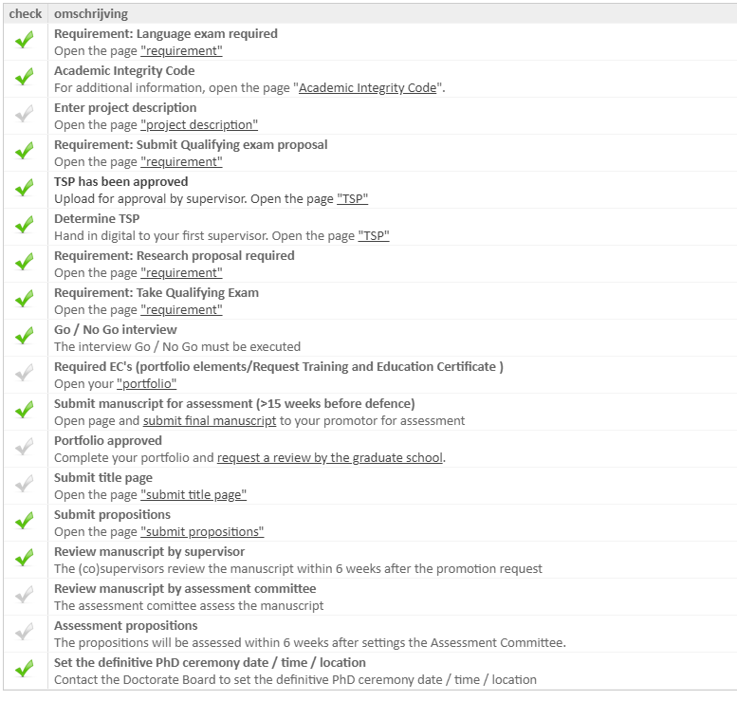
- Go to “Required EC's (portfolio elements/Request Training and Education Certificate )” and click the option “Open your "portfolio"”

- Enter a new activity on the “training activity – Items page” by pressing the “new” button
- Follow the instructions to upload the certificate request; do not forget to upload the document with the request for the certificate that includes the signature of the PhD programme coordinator.
Do not forget to press “save” when you have uploaded the document.
- Send an email to PE&RC office that you have uploaded your certificate request

Accordingly PE&RC office approves the submission in Hora Finita. You will receive an email about this and two green check marks (for required ECs and Portfolio approved) will appear in your PhD checklist.

